SCHOOL OF MATERIALS SCIENCE & ENGINEERING

CONTINUOUS ASSESSMENT 1 SEMESTER 1 2024-2025

MS1016 – THERMODYNAMICS OF MATERIALS

(Question Sheet)

6 November 2024 Time Allowed: 1 hour

INSTRUCTIONS

1. This paper contains THREE (3) short questions and TEN (10) MCQ questions.

2. Answer ALL questions.

3. Write all answers on the answer sheet provided and clearly write your name and matriculation number on it.

4. This is an open-notes test.

5. All questions have ONLY ONE correct answer for the MCQ questions.

6. You may retain this question sheet. Only answers on the submitted answer sheet will be considered.

PART I – SHORT QUESTIONS
- Derive the equation of standard Gibbs free energy of reaction ∆G°:
∆G° = −RTlnKa
Calculate the equilibrium O₂ pressure for the following oxidation reaction at 1200 K:
$\frac{4}{3}$Al (solid)+ O₂ (gas) → $\frac{2}{3}$Al₂O₃ (solid)
Given the ∆G° for this reaction is -810KJ/mol, ideal gas constant R is 8.314 J/Kmol.
- marks)
Consider a reaction: bB + cC = dD + eE,
δWrev = ∆G = ∆Gº + RT ln J (2 marks), J = $\frac{{[D]}^{d}{[E]}^{e}}{{[B]}^{b}{[C]}^{c}}$ (2 marks)
At equilibrium, J is called the equilibrium constant, Ka (1 mark)
At equilibrium, ∆Gº = 0, ∆Gº = −RTlnKa (2 marks)
For the given reaction: $\frac{4}{3}$Al + O₂ → $\frac{2}{3}$Al₂O₃
The equilibrium constant: Ka = $\frac{{[Al2O3]}^{\frac{2}{3}}}{{[Al]}^{\frac{4}{3}}[O2]}$ (1mark)
Since Al and Al₂O₃ are solids, the fugacity is considered as 1 (2 marks), and for ideal gas at pressure approaches zero, the fugacity is equal to its pressure. (2 marks)
Therefore, Ka = $\frac{1}{P_{O2}}$ (1 mark), ∆Gº = RTlnP_{O2} (1 mark)
At 1200 K, ∆Gº = −810,000 J/mol = 8.314 × 1200 lnP_{O2} (2 marks)
lnP_{O2} = −81.2 atm (2 marks)
Therefore, the equilibrium O2 pressure P_{O2} = 5.50 × 10-36 atm. (2 marks)

- Given the following data on graphite and diamond:
Density of graphite = 2.25 g/cm³
Density of diamond = 3.51 g/cm³

 | ΔH° (kJ/mol) | ΔS° (J/mol.K)
Diamond | 1.897 | 2.38
Graphite | 0 | 5.74

- At 298 K, what is the Gibbs free energy change (ΔG) for the following reaction?
C_{graphite} = C_{diamond}
(4 marks)
- Is the diamond thermodynamically stable relative to graphite at 298 K? (2 marks)
- What is the change in Gibbs free energy of diamond when it is compressed isothermally from 1 to 1000 atmosphere? (4 marks)
- Assuming that graphite and diamond are incompressible (K_{T} = 0), calculate the pressure at which the 2 exist in equilibrium at 298 K. (6 marks)
- In industrial practice, diamond is synthesized from graphite to diamond at high pressure and temperature. Explain qualitatively, why the need for high temperature. (4 marks)

- Answer the following questions.
- Define Activity (3 marks)
- Roughly sketch figure 1 onto your answer sheet, thereafter, circle the melting point of A, B and the eutectic point. (3 marks)
- At a given temperature, T₁, component B dissolves 1.4 wt. % A and component A dissolves 2.4 wt. % B. Calculate the activity coefficient of B in A and A in B. No intermediate phases exist in the binary system. (14 marks)

- The activity of a component i, a_{i} is defined as the ratio of the fugacity of the material to the fugacity in its standard state. (1 mark)
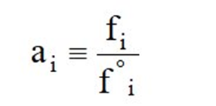(1 mark)

Where fºi is the fugacity of the material in its standard state, usually
is pure gas at 1 atm. For solid or liquid, the standard states is
pure material at 1 atm where activity is 1. (1 mark)

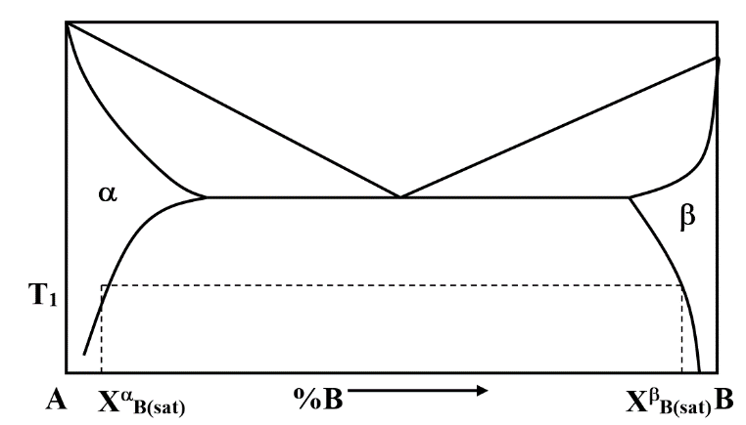
Melting point of A
Eutectic point
Melting point of B
1 mark each
- At T₁, phase a is in equilibrium with phase b, meaning the chemical potential of A is the same in both phases, i.e.
μ_{A}^{α} = μ_{A}^{β} (1 mark), μ_{B}^{α} = μ_{B}^{β} (1mark)
Since α and β are dilute solutions (1 mark), at the respective end of the phase diagram, Henry’s Law is obeyed by the solutes & Raoults’ Law is obeyed by the solvent (1 mark)

Using component B for computation, in the dilute phase b, X_{B}^{β}, component B is the solvent, and it follows Raoults’ Law where γ_{B} = 1 (1 mark). Thus
μ_{B}^{β} = G_{B} + RT ln a_{B}^{β} = G_{B} + RT ln X_{B}^{β} (1) (2 marks)
In the saturated phase α, X_{B}^{α}, component B is the solute, and it follows Henry’s Law (1 mark). Thus
μ_{B}^{α} = G_{B} + RT ln a_{B}^{α} = G_{B} + RT ln γ_{B}X_{B(sat)}^{β} (2) (2 marks)
Since the 2 phases exist together at T₁, they must be in equilibrium and therefore the chemical potential of B in α is equal to the chemical potential of B in β. Hence equating (1) and (2):
G_{B} + RT ln X_{B}^{β} = G_{B} + RT ln γ_{B}X_{B(sat)}^{α} (1 mark)

ln X_{B}^{β} = ln γ_{B}X_{B(sat)}^{α}

ln X_{B}^{β} = ln γ_{B} + lnX_{B(sat)}^{α}

ln γ_{B} = ln X_{B}^{β} - ln X_{B(sat)}^{α}

γ_{B} = X_{B}^{β} / X_{B(sat)}^{α} (1 mark)

γ_{B} = 0.986 / 0.024 = 41.08 (1 mark)

Similarly
γ_{A} = 0.976 / 0.014 = 69.71 (1 mark)

PART II Multiple Choice Questions

Answer all the TEN MCQ questions below. There is only ONE answer for each question. (4 marks each)

- A pressure-temperature phase diagram, the conditions under which a component system exist as 3 phases in equilibrium corresponds to
- A point
- A line
- An area
ANS: A
- The entire diagram
- None of the above

Explanation: Eutectic point

- The fugacity of a certain gas equals to its pressure if and only if
- The pressure of the gas is sufficiently high.
ANS: D
- The molar weight of the gas is sufficiently low.
- The molecules inside the gas interact strongly with each other.
- The gas is heavily rarefied and interactions between molecules are negligible.
- None of the above is correct.

Explanation: Fugacity is a corrected pressure that accounts for deviations from ideal gas behavior. For an ideal gas, where the interactions between molecules are negligible, fugacity equals the pressure. This typically occurs when the gas is at low pressure and is not dense, so the interactions between gas molecules are minimal

- The following figures are the free energy curves of a binary system containing A and B. Which of the following statement are correct?
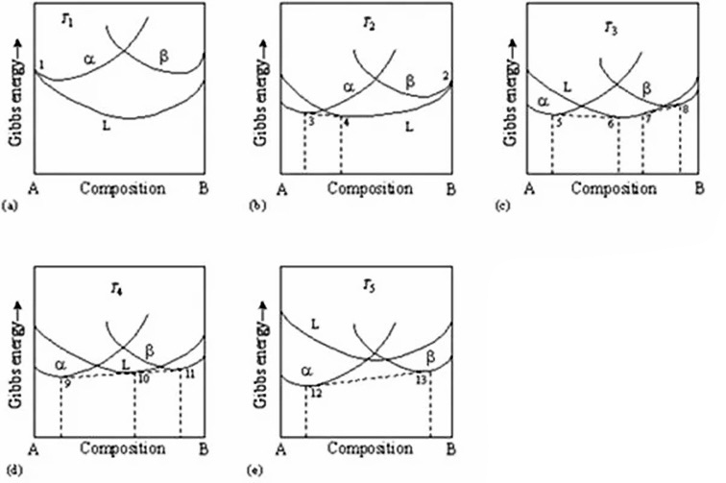
ANS: D
T₅
T₄
T₃
T₂
T₁

- T₁ is the highest temperature and T₅ is the lowest.
- T₁ is the lowest temperature and T₅ is the highest.
- A and B has complete miscibility in each other.
- A and B have limited solubility in each other.
- Melting point of A > B.
- Melting point of A < B.
- There is a eutectic point in this binary phase diagram.

- I, IV, VI, VII
- I, III, VI, VII
- II, IV, VI, VII
- I, IV, V, VII
- II, III, V, VII

Explanation: The lowest Gibbs energy curve in T₁ is liquid, thus, indicating that the binary system is in the liquid phase. On the other hand, T₅ lowest Gibbs energy curve is alpha and beta, indicating that it’s in the alpha-beta phase (solid). Thus, T₁ is highest while T₅ is lowest.
In the phase diagrams, there is two distinct solid phases, α and β, indicating that A and B do not form a completely miscible solid solution. The phase boundaries show partial miscibility.
The Gibbs energy curve of A intersects the liquid curve (L) at a higher temperature than B, indicating that A has a higher melting point.
The intersection of the liquidus curve with the solid phases α and β forms a eutectic point.
So, the correct answer is D

- Water on melting and has the fusion curve with a slope.
  - contracts, negative
ANS: A
  - contracts, positive
  - expands, negative
  - expands, positive
  - None of the above

Explanation: Unlike other substances which expands on melting, water contracts on melting and hence the slope of the fusion curve is negative. So, the correct answer is A

- The activity of zinc in a copper zinc alloy having 30.6% zinc by mass is 0.036 at 773 K. The atomic mass of copper is 63.55 g/mol and that of zinc is 65.38 g/mol. The value of the activity coefficient?
  - −0.12
  - 0.12
ANS: B
  - −0.14
  - 0.14
  - None of the above

Explanation: In 100 g of alloy,
Moles of zinc= (30.6/65.38) =0.468 mol
Moles of copper= (69.4/63.55) =1.092 mol
Total moles= 0.468+1.092= 1.560 mol
Mole fraction of zinc= 0.468/1.560 = 0.3
Activity co-efficient= 0.036/0.3 =0.12
So, the correct answer is B.

- Water boils at 100 °C under 1 atmospheric pressure (10⁵ Pa). The heat of vaporisation is 40.65 J/g. Using the Clapeyron equation, the boiling point of water at Mount Everest (8848 m above sea level where pressure is 33.7 × 10³ Pa) is:
  - 71 K
  - 171 K
  - 71 ºC
ANS: C
  - 121 ºC
  - 171 ºC

Explanation: The Clapeyron equation for vapour (steam)in equilibrium with liquid water is

${\left(\frac{\text{dP}}{\text{dT}}\right)}_{\text{eq}}=\frac{1}{{\underline{V}}_{vapour}}\frac{∆{\underline{H}}_{vap}}{T}$ where ΔH_{vap} is the heat of vapourisation = 40.65 J/g

By integrating the Clapeyron, it can be shown that [PV=RT]:

$$ln\frac{P_{2}}{P_{1}}=\frac{{\underline{H}}_{vap} }{R}\left[\frac{T_{2}-T_{1}}{T_{2}T_{1}}\right]$$

Water at Mount Everest boils at about 71°C. So, the correct answer is C

- If a system consists of five components and three phases, how many degrees of freedom does it have according to the Gibbs Phase Rule?
- 0
- 1
- 2
ANS: E
- 3
- 4

Explanation:
The Gibbs Phase Rule describes as: $f=2-P+c$, substituting with the values, the degree of freedom f = 2 $–$ 3 + 5 = 4. So, the correct answer is E.

- Which of the following statements correctly describes chemical equilibrium.
- The Gibbs free energy change is positive, and the reaction continues indefinitely.
- The reaction rates of the forward and reverse reactions are zero.
- There is no net change in the concentration of reactants and products.
- The reaction rate of the forward reaction is greater than the reverse reaction.
- The temperature of the system continuously changes to maintain equilibrium.
ANS: C

Explanation:
At chemical equilibrium, the free Gibbs energy change is zero. The rates of the forward and reverse reactions are equal, resulting in no net change in the concentrations of reactants and products, but both reactions continue to occur. So, the correct answer is C.

- How can reaction: 2H₂ + O₂ → 2H₂O be used to control the equilibrium partial pressure of O₂ for metal oxidation?
- By adjusting the temperature without changing the pressure.
ANS: D
- By changing the reaction volume at constant temperature.
- By altering the Gibbs free energy of the system directly.
- By manipulating the H₂ to H₂O ratio according to the Ellingham diagram.
- By ensuring that the H₂ concentration is always lower than that of H₂O.

Explanation:
According to the chemical reaction: 2H₂ + O₂ → 2H₂O, at the equilibrium, K_{a} = $\frac{P_{H2O}^{2}}{P_{H2}^{2}P_{O2}}$, and $P_{O2}= \frac{1}{Ka}{(\frac{P_{H2O}}{P_{H2}})}^{2}$. Therefore, the O₂ pressure can be controlled by the ratio of H₂ to H₂O, which in equilibrium with metals and oxide can be determined from the Ellingham diagram. So, the correct answer is D.

- Which of the following metal oxides can be reduced by hydrogen gas (H₂) at the temperature of 1500 ºC (refer to Ellingham diagram)?
- CoO
- ZnO
- MgO
ANS: A
- Al₂O₃
- ZrO₂

Explanation:
Refer to the Ellingham diagram, at the given temperature of 1500 ºC, the oxidation equilibrium lines of ZnO, MgO, Al₂O₃ and ZrO₂ are under the line of H₂ → H₂O, and the oxidation line of CoO is above the line of H₂. Therefore, the correct answer is A.

Ellingham Diagram
